CIS 18A Course Project Program Pseudocode and Documentation Maia Nguyen

1. The business that I chose for this project is a coffee shop.
2. My company name is “The Software Nguyen-geneer”
3. Pseudocode will be posted at the bottom of this document\*
4. This program is created for use at a coffee shop/café. Intended users are baristas/workers at a coffee shop/café who will use it as a Point of Sale system to take orders and calculate the total price for the order. The technical function is to hold the values for the requested item and adding the item values together to calculate a total value.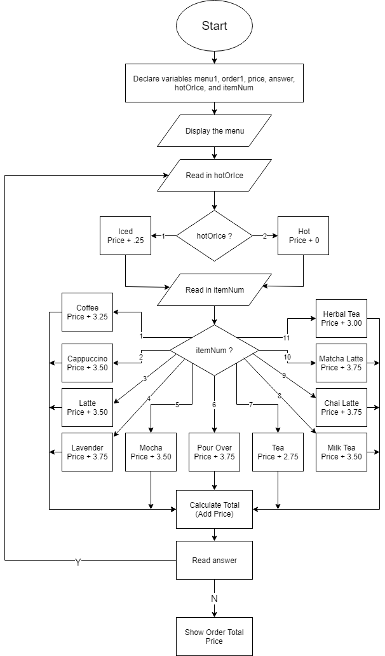

FLOWCHART:

Stop

\*PSEUDOCODE:

PRINT the menu

DO these things:

PROMPT user for answer for a hot or iced drink

CASE hot/ice answer

HOT: add 0 to price

ICE: add .25 to price

PROMPT user for item number to add to the order

CASE item number answer

1: Coffee is ordered, add 3.25 to price

2: Cappuccino is ordered, add 3.50 to price

3: Latte is ordered, add 3.50 to price

4: Lavender Latte is ordered, add 3.75 to price

5: Mocha is ordered, add 3.50 to price

6: Pour Over is ordered, add 3.75 to price

7: Tea is ordered, add 2.75 to price

8: Milk Tea is ordered, add 3.50 to price

9: Chai Tea Latte is ordered, add 3.75 to price

10: Matcha Latte is ordered, add 3.75 to price

11. Herbal Tea is ordered, add 3.00 to price

CALCULATE total price by adding prices so far to total price

PROMPT user for another drink to add to the order

WHILE: add another drink answer is YES

IF add another drink answer is NO, show the total price for the order after adding tax to the total price